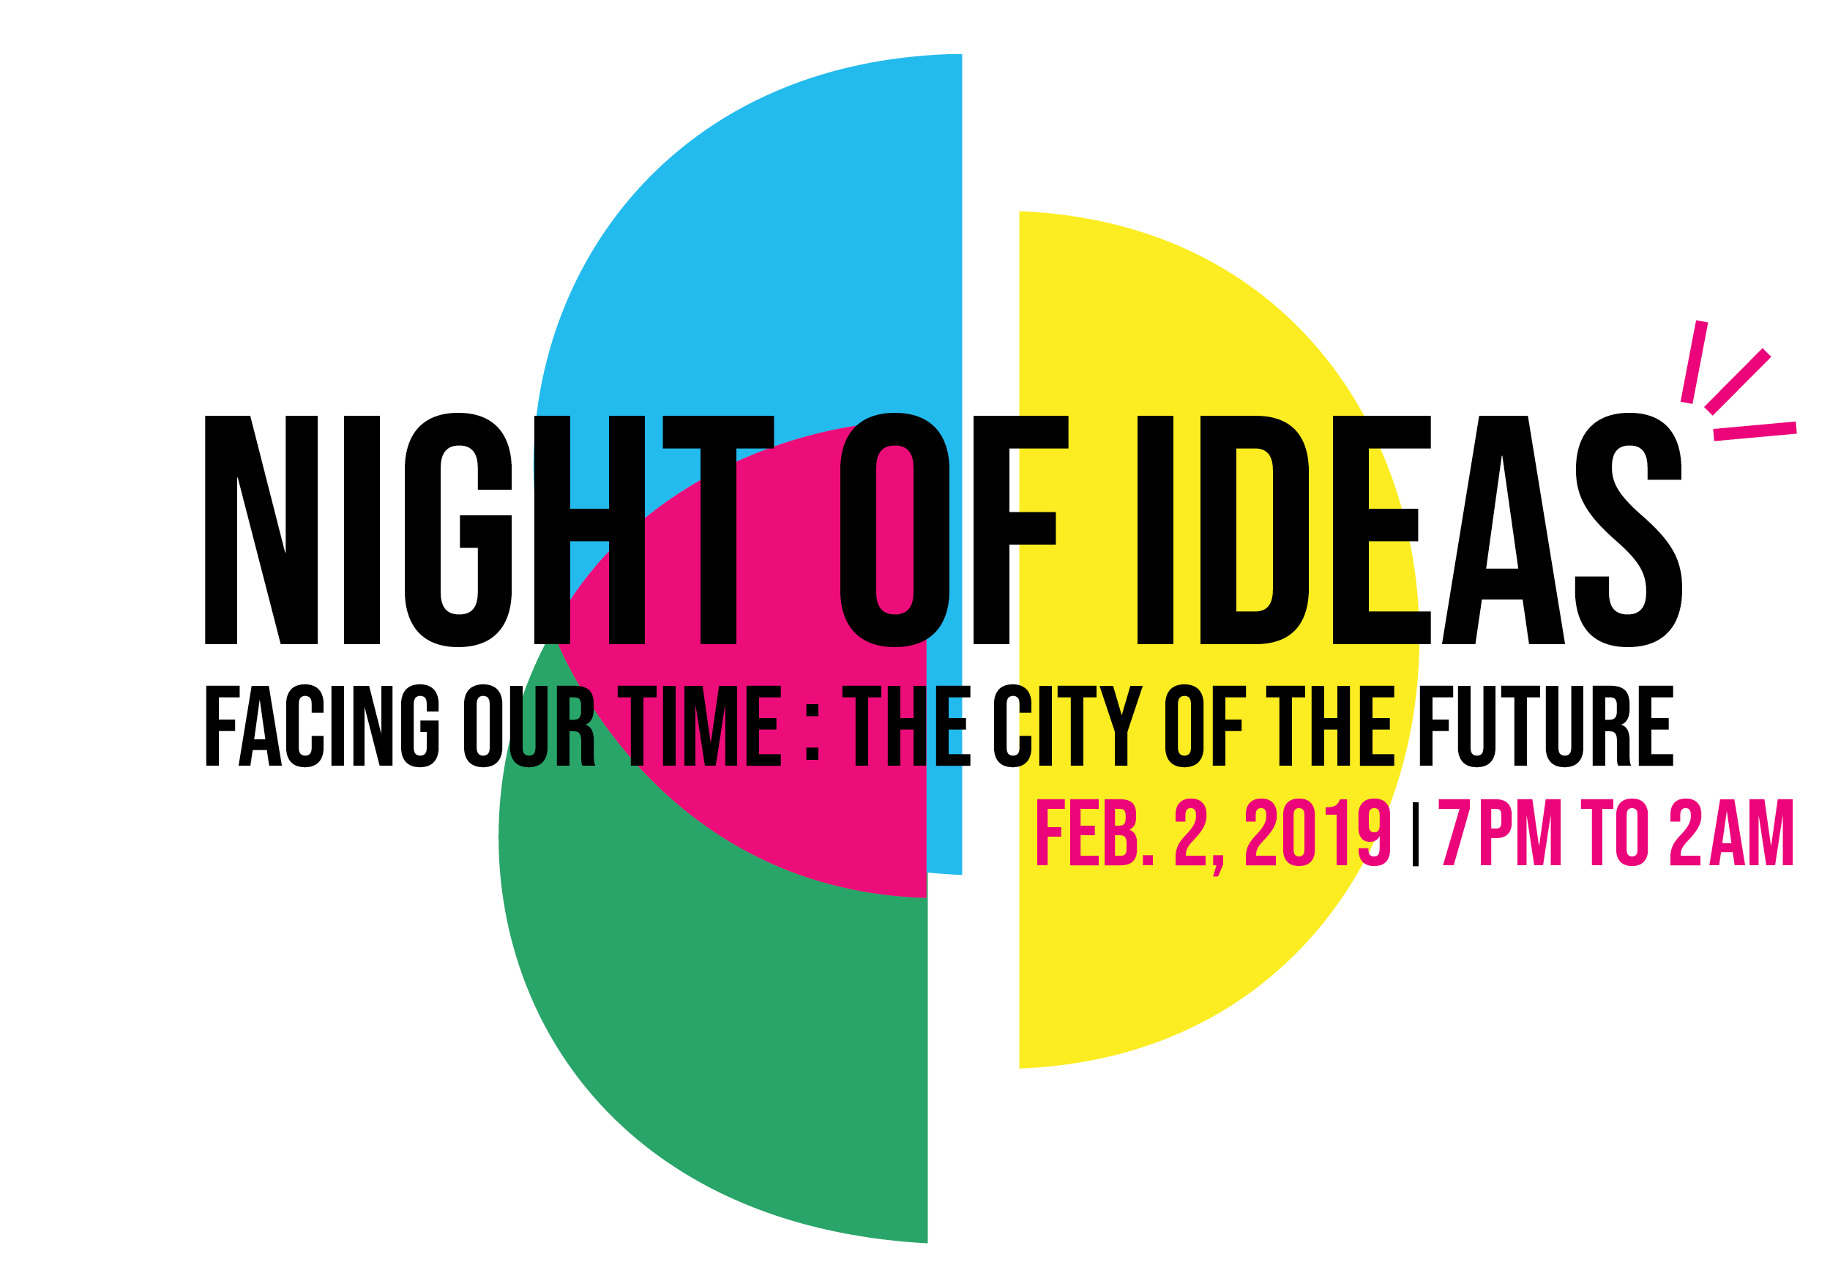

FOR IMMEDIATE RELEASE

THE FRENCH CONSULATE, SAN FRANCISCO PUBLIC LIBRARY AND SFMOMA TEAM UP TO PRESENT NIGHT OF IDEAS
IN SAN FRANCISCO ON FEBRUARY 2, 2019

FREE event features Mayor London Breed, artist JR, Chef Dominique Crenn, French Ambassador to the United States Gérard Araud and host of KQED’s Forum Michael Krasny

SAN FRANCISCO, CA (January 8, 2019) – The French Consulate in San Francisco, San Francisco Public Library (SFPL) and San Francisco Museum of Modern Art (SFMOMA) jointly announce the first San Francisco edition of the global marathon event Night of Ideas on February 2, 2019, from 7 p.m. to 2 a.m., at the San Francisco Main Library. Presented in collaboration with the City of San Francisco and a vibrant ecosystem of local cultural, science, tech and academic partners, this free seven-hour marathon of philosophical debate, talks, performances, and music features top thinkers from San Francisco and beyond in a format designed to spur dialogue on the theme “Facing our Time: the City of the Future.”

With keynotes, panels and presentations by diverse voices including Mayor London Breed, artist JR, (whose video mural The Chronicles of San Francisco opens at SFMOMA in May 2019), Dominique Crenn, chef/owner of the three Michelin-starred restaurant Atelier Crenn, Gérard Araud, French Ambassador to the United States, John Law, Founder of Burning Man, architect Nicola Delon, designer of the French pavilion at the Venice Biennale, Dominique Alba, director of the Paris Urbanism Agency, Michael Krasny, host of Forum on KQED, and Allison Arieff, editorial director of SPUR, the San Francisco edition of Night of Ideas expects thousands to participate in the evening’s exchange of ideas and creative dialogue.

Multiple stages throughout the Main Library will host concurrent programming, music and dance performances, yoga, breakout sessions and opportunities for engagement and debate amongst the attendees. More than 30 topics relating to the City of the Future will be explored over the course of the evening on multiple floors of the Main Library including civic imagination, arts, accessibility, equity, literature, film, games, food, transportation, media, city planning, play and much more. A full list of speakers, panelists and performers will be announced at a later date.

“San Francisco is a creative city that draws inspiration from the people in our neighborhoods as well as cultures all over the world,” said Mayor London N. Breed. “I’m excited by the line-up of innovative, international thinkers coming together at the Main Library and I invite all of San Francisco and the Bay Area to participate in the Night of Ideas and to share your thoughts and dreams about the future of our great city.”

“I am very pleased to see the first edition of La Nuit des Idées in San Francisco,” said Emmanuel Lebrun-Damiens, Consul General of France. “Thanks to this global initiative launched in Paris in 2015, thousands of people gather and celebrate ideas on the same night in more than 100 cities in the world. As time accelerates and innovation constantly disrupts our lives, there is no better place than San Francisco to discuss this 2019 theme: the City of the Future.”
"Art reflects the issues of our time, and reimagines possibilities for the future. Through its partnership with the San Francisco Public Library, SFMOMA has created accessible and imaginative experiences related to the profound shifts taking place in San Francisco. We are thrilled to be partnering with so many local and international thought leaders on the inaugural Night of Ideas in San Francisco, and to celebrate the city, its community and its ideas,” said Neal Benezra, the Helen and Charles Schwab Director of SFMOMA.
“We’re delighted to open up the Main Library for the community to learn, share ideas, have fun and experience something completely new to San Francisco,” said Michael Lambert, Acting City Librarian of San Francisco Public Library. “It’s an opportunity for diverse groups to connect and have engaging dialogues about the future.”

Night of Ideas is free to the public but registration is required.

ABOUT NIGHT OF IDEAS

Co-produced in the United States by the Cultural Services of the French Embassy, the Institut Français and local partners, Night of Ideas has been mounted in New York City since 2015 and in Los Angeles since 2017. Last year, more than 7,000 guests attended Night of Ideas at the Brooklyn Public Library in New York. The event begins in Paris on Jan. 31, 2019 and is held annually in more than 120 cities around the world. The 2019 U.S. cities are:
- Houston at Rice University’s Moody Center for the Arts - Jan. 26
- Washington D.C. at the Hirshhorn Museum and Sculpture Garden - Jan. 31
- Los Angeles at The Museum of Natural History - Jan. 31
- New York City at the Brooklyn Public Library - Feb. 2
- San Francisco at the San Francisco Public Library - Feb. 2
NIGHT OF IDEAS PROGRAM OF EVENTS

Night of Ideas is free to the public but guests should register online on Eventbrite to guarantee a spot. The doors of the Main Library at 100 Larkin Street (between Grove and Fulton streets) will open at 7 p.m. for check in. Seven hours of programming will conclude at 2 a.m.

The programming will unfold as follows:

7:00 p.m. The Main Library opens to host a seven-hour line-up of diverse events and thought-provoking debates. Food, beverages and wine will be available throughout the night.

7:30 p.m. Mayor of San Francisco London Breed will officially launch the celebration, along with co-presenters of Night of Ideas. Music and dance performances will welcome the public in the library atrium.

8:00 p.m. to 9:00 p.m. Poets, thinkers, urbanists and students will explore themes such as “poetic city,” “transit city,” and “teen city” while Michael Krasny hosts a two-hour special live remote broadcast of KQED’s Forum.

9:00 p.m. onwards An open mic stage will allow the public to share their thoughts and ideas for tomorrow’s cities while SFMOMA, the Institute for the Future, Civic Common Center and KQED – among others – will offer panels relating to the themes “equitable city,” “media city,” and “welcoming city.” Music, dancing and yoga will be interspersed to energize participants and break social barriers.

10:00 p.m. Additional themes will be curated by Atelier Crenn, National Park Service, Litquake and the James C Hormel LGBTQIA Center among others. In the atrium, Dominique Alba, director of the Parisian Urbanism Agency, will present a keynote.

11:00 p.m. French artist JR will wonder how an entire city can be represented through arts. The Institute for the Future will experience the power of civic imagination with the audience, while Bring Your Own Wheels will explore how to adapt to an ever-changing physical and psychological city landscape.

From midnight to 2 a.m. Burning Man Project and Mutek.SF will wrap up the night along with keynotes, DJ sets, yoga classes and musical performances. Nicola Delon, designer of the French pavilion at the Venice Biennale, will join them to end this exceptional event!

NIGHT OF IDEAS CONTEST– Win two pairs of roundtrip air tickets to Paris

Guests at Night of Ideas will have the opportunity to win two pairs of roundtrip tickets to Paris during the evening by participating in an Instagram contest sponsored by airline French Bee. Participants may simply post a picture of any of the activities of Night of Ideas on their Instagram account and tag it #NightofIdeasSF. Winners will be randomly selected at the end of the night and must be present to win. A complete list of contest rules will be available on the website.

PRESENTERS AND SPONSORS

Night of Ideas is co-presented by the San Francisco Public Library, the French Consulate in San Francisco, and SFMOMA in collaboration with media partner KQED and the City and County of San Francisco.

The event is made possible by the support of Friends of the San Francisco Public Library, 836M, the Cultural and Scientific Services of the French Embassy in the United States and the French American Cultural Society. La Nuit des Idées is a project of the Institut Français and Fondation de France.

Co-presenters:

The General Consulate of France in San Francisco, the Cultural and Scientific Services of the French Embassy represent France’s cultural, scientific, political and economic interests in Northern California and ten other states (Alaska, Guam, Hawaii, Idaho, Montana, North Nevada, Oregon, Utah, Washington and Wyoming). While providing various consular services to French nationals, the General Consulate is a platform which promotes cooperation, innovation and mutual understanding between France and the U.S. The Night of Ideas is part of the After Tomorrow season.

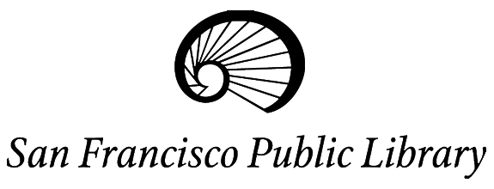
San Francisco Public Library is dedicated to free and equal access to information, knowledge, independent learning and the joys of reading for our diverse community. The library system is made up of 27 neighborhood branches, the San Francisco Main Library at Civic Center and four bookmobiles.

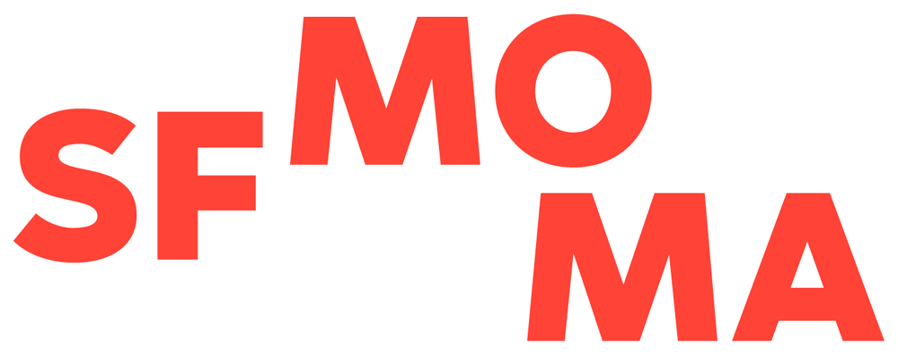
SFMOMA is dedicated to making the art for our time a vital and meaningful part of public life. Founded in 1935 as the first West Coast museum devoted to modern and contemporary art, a thoroughly transformed SFMOMA, with triple the gallery space, an enhanced education center and new free public galleries, opened to the public on May 14, 2016. The expanded museum has welcomed more than 1 million visitors each year. The Night of Ideas is part of the Public Knowledge program.

Media Partner

KQED Public Media for Northern CA, the first ranked radio station in the Bay Area and one of the most listened-to public radio stations in the United States will organize two hours of Forum, hosted by Michael Krasny, on the San Francisco Public Library stage at the event.

Curating Partners

Numerous renowned local institutions worked together to create the content for Night of Ideas. Among them, Atelier Crenn, Burning Man Project, City Lights Bookstore, Civic Center Commons, Consulate General of the Federal Republic of Germany, Hormel LGTBQIA Center, Institute for the Future, Litquake Festival, Lycée français de San Francisco, Mutek.SF, National Park Service, Open Austria, SFFILM, SPUR, Stanford University, Ubisoft, UC Berkeley and Youth Speaks.

Performances

Night of Ideas will offer performances by: Awesome Orchestra Collective, Bay Area Flash Mob, Steve Silver’s Beach Blanket Babylon, Burning Man Project, Exploratorium, Outdoor Yoga SF, RAWdance, San Francisco Sound Wave, Solenn Seguillon and Aleron Trio, among others.

Main Partners

The event is made possible with the support of Friends of the San Francisco Public Library, 836M, the Cultural and Scientific Services of the French Embassy in the United States and the French American Cultural Society.

In-kind Partners

We thank French Bee and Intercontinental San Francisco for their contributions.

MEDIA CONTACTS

Matthias Carette
Press Officer - French Consulate in San Francisco
Matthias.carette@diplomatie.gouv.fr
Tel: 1 – (415) 616 4907
Cell: 1 – (415) 516 0604

Mindy Linetzky
Manager, Communications & Public Affairs – San Francisco Public Library
mindy.linetzky@sfpl.org
Tel: 1 – (415) 557 4252

Jill Lynch
Communications Director – SFMOMA
jilynch@SFMOMA.org
Tel: 1 – (415) 357 4172

Follow Night of Ideas!
www.nightofideassf.com

A Media Kit with images, video and more is available here

#nightofideasSF

